Version 1.0

20/11/2019

Register application in AZURE

POP BRIDGE

ITESOFT

# REGISTER APPLICATION IN AZURE

Before being able to use Azure AD authentication (aka Modern Authentication) using one the the authentication flows, you need to register the POP Bridge application into your Azure AD tenant.

Execute the following steps:

1. Sign into [Azure Portal - App Registrations](https://go.microsoft.com/fwlink/?linkid=2083908) using your organization account.
   * <https://portal.azure.com/#blade/Microsoft_AAD_IAM/ActiveDirectoryMenuBlade/RegisteredApps>
2. Choose **New registration**.
   * In the **Name** section, enter a meaningful application name that will be displayed when authenticating
   * In the **Supported account types** section, select **Accounts in any organizational directory**
   * Select **Register** to create the application.

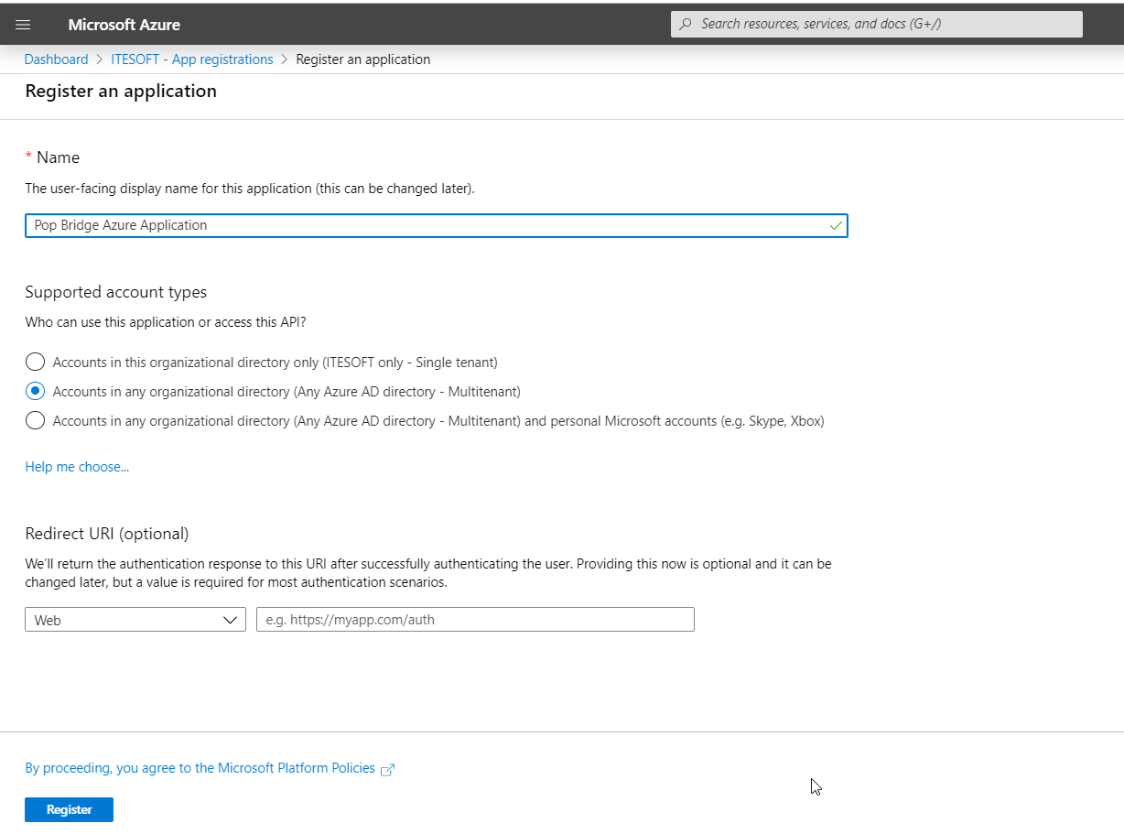

The application's Overview page shows the properties of your app.

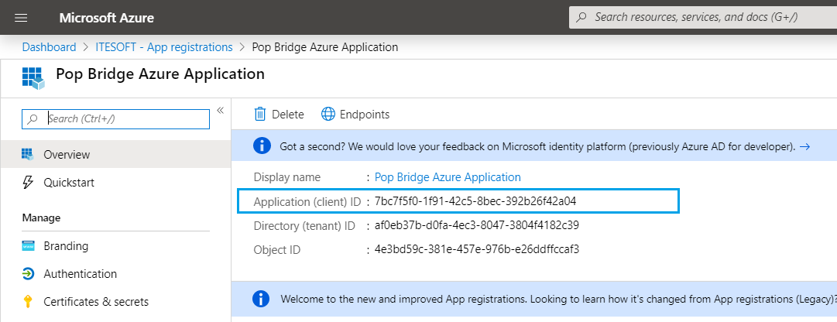

1. Copy the **Application (client) Id**. This is the unique identifier for your application.
2. You'll have to keep it and provide as the **clientid** in Pop Bridge application argument for MSGRAPH authentication flow.
3. In the application's list of pages, select **Authentication**.

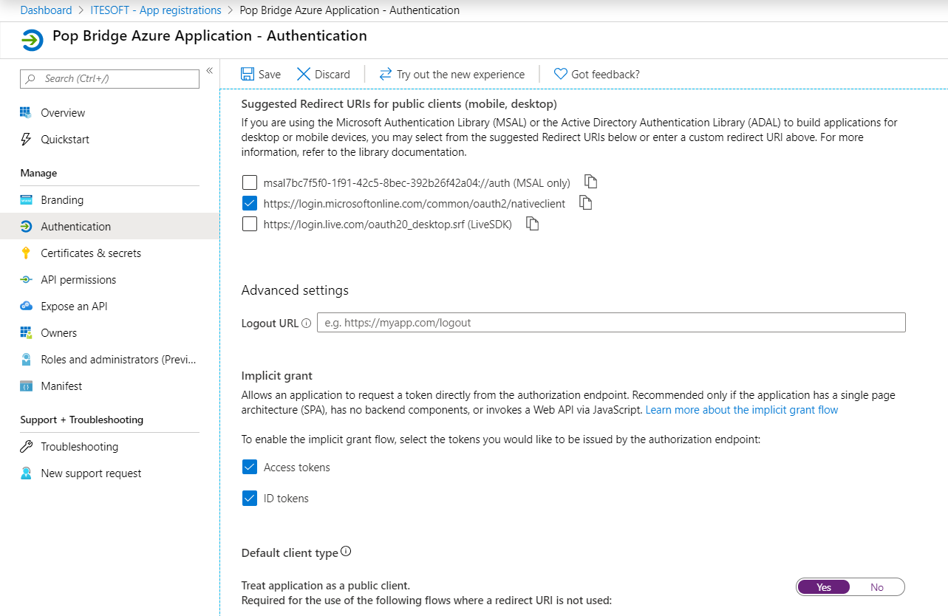

1. Under **Redirect URIs** in the **Suggested Redirect URIs for public clients (mobile, desktop)** section, check the box next to:
   * <https://login.microsoftonline.com/common/oauth2/nativeclient>
2. Under **Default client type** select **Yes** for the setting **Treat the application as public client**
3. Choose **Save**.